Research progress for Giovanni’s Experiment 2

**Brief statement of goal**

The results of our recent study (Zani, Butterfill, & Low, 2020) suggest that in a real-time interactive task adults’ fast believe tracking abilities and motor processes are functionally related. To extend on this, we tested if, and the extent to which, adults’ eye gaze, postural sway and hand movement trajectories are modulated while tracking the belief of an agent who is physically restrained. While expecting to replicate our previous findings in the control condition (when the agent does not have body restrains) in terms of belief-congruent anticipatory looking (with participants looking first and longer at the location where the other person believes the object is) and body leaning (with participants leaning more towards the location they anticipate that the other person will go to) we also propose that interfering with the agent’s motor system would disrupt participants’ fast belief-tracking abilities and that this would emerge in terms of lack of belief congruent modifications of anticipatory gazing and postural sway. In addition, we expect that when participants are asked to help the agent by clicking one out of two boxes, their hand trajectory would be influenced by the agent’s belief when she is not restrained (with an attraction effect of the cursor’s trajectory toward the belief congruent location) but not when the agent is restrained.

**Participants**

57 subjects took part in the experiment (33 female and 24 male).

**Stimuli**

4 video clips were adopted as experimental stimuli (see Fig.1 for a schematic representation of their time sequence):

1. True Belief Untied (TBU): after the agent has placed a chocolate bar in one of the two boxes, the experimenter (watched by the agent) moves the chocolate bar from that box to the other. Then the agent leaves the room. While the agent is outside the room, the experimenter locks the boxes with a black pin. Note that the locking mechanism can be seen from the participant’s point of view but cannot be seen by the agent. At this point the agent comes back into the room and, after 1200 ms, she reaches for the empty box. After unsuccessfully trying to open the lid, the agent assumes a neutral position and a sentence saying “help me” appears on the screen.
2. False Belief Untied (FBU): after placing a chocolate bar in one of the two boxes, the agent leaves the room. While the agent is outside, the experimenter moves the chocolate bar from one box to the other and he locks the boxes with a black pin. Note that the locking mechanism can be seen from the participant’s point of view but cannot be seen by the agent. At this point the agent comes back into the room and, after 1200 ms, she reaches for the empty box. After unsuccessfully trying to open the lid, the agent assumes a neutral position and a sentence saying “help me” appears on the screen.
3. True Belief Tied (TBT): after the agent has placed a chocolate bar in one of the two boxes, the experimenter (watched by the agent) moves the chocolate bar from that box to the other. Then the agent leaves the room. While the agent is outside the room, the experimenter locks the boxes with a black pin. Note that the locking mechanism can be seen from the participant’s point of view but cannot be seen by the agent. When the agent comes back into the room it is clear that her ability to move is impaired by bandages blocking her arms and legs. After 1200ms the agent leans towards the the empty box. Then the agent assumes a neutral position and a sentence saying “help me” appears on the screen.
4. False Belief Tied (FBT): after placing a chocolate bar in one of the two boxes, the agent leaves the room. While the agent is outside, the experimenter moves the chocolate bar from one box to the other and he locks the boxes with a black pin. Note that the locking mechanism can be seen from the participant’s point of view but cannot be seen by the agent. At this point the agent comes back into the room and it is clear that her ability to move is impaired by bandages blocking her arms and legs. After 1200 ms the agent leans towards the empty box. Then the agent assumes a neutral position and a sentence saying “help me” appears on the screen.

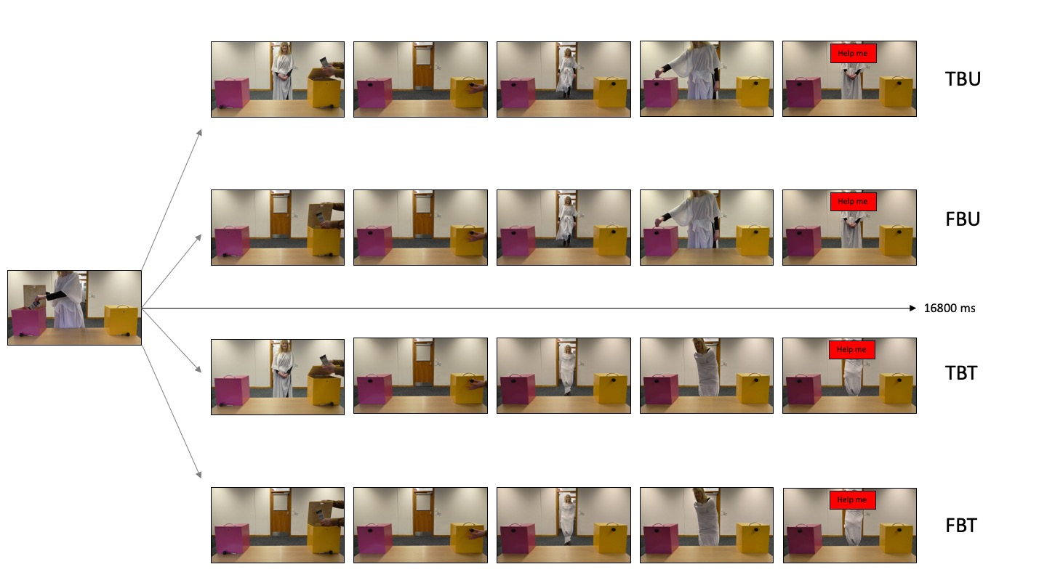

Figure 1: schematic representation of the experimental conditions. True Belief Untied (TBU); False Belief Untied (FBU); True Belief Tied (TBT); False Belief Tied (FBT).

**Procedure**

Participants were tested individually in a single experimental session lasting approximately 1 h. They were asked to stand on a Wii balance board with the right hand holding a mouse and the left hand comfortably resting on the table. They were instructed to watch the video clips that were presented on a monitor in front of them and to unlock one of the two boxes by clicking on it every time that the agent asked for help. Participants watched 18 videos per condition, for a total of 72 trials. The order of the videos and the initial location of the chocolate was randomized across participants.

**Data analysis**

After cleaning the raw data, we are planning to perform multi-level models analysis separately for each measure (Wii Balance Board, Eye-tracker and Mouse-Tracker) and then to investigate the existence of similar patterns among different measures by using cluster analysis and correlations.

**Results**

Although formal analysis has yet to be performed, initial evidence coming from the Wii Balance Board seems to confirm our hypothesis that adults’ motor processes successfully interface with belief-tracking abilities when the observed agent’s motor abilities are intact: participants lean more toward the belief congruent location in both TB (M=0.002; s.d.=0.04) and FB (M=-0.003; s.d.=0.05) conditions when the agent can motorically interact with the environment compared to TB (M=0.0008; s.d.=0.06) and FB (M=-0.001; s.d.=0.04) conditions of when the agent is motorically impaired.

Figure 2: Graphical representation of displacement from body midline (0) split for belief state (TB, FB) and body restrain (Untied, Tied). Positive values reflect a leaning towards the box with the object in it (now-full box); negative values reflect a leaning towards the box in which the object was initially located (now-empty box)